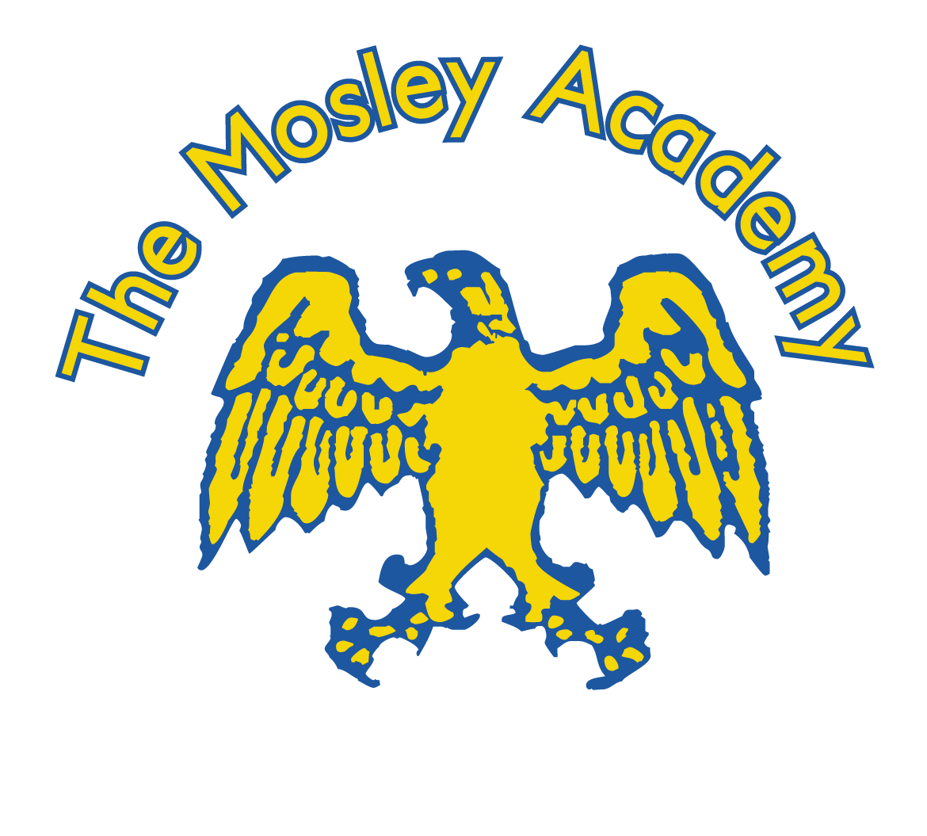

THE MOSLEY ACADEMY

SEPTEMBER 2021
Review:
September 2022

SEPTEMBER 2021
Review:
September 2022

NOVEMBER 2021
Review:
November 2023

Anti-Bullying Procedure
2025/2026

Revised March 2026
Annually
SEPTEMBER 2021
Review:
September 2022

SEPTEMBER 2021
Review:
September 2022

At The Mosley Academy we take a strong stand to eliminate bullying behaviour.

As a school we sign and uphold our commitment to the school’s anti-bullying pledge and continually review our actions through surveys and ongoing engagement with the whole school community. Our anti-bullying message is promoted regularly through assemblies, anti-bullying week, our PSHE curriculum and our school values of: honesty, kindness, respect, acceptance, happiness, resilience and independence.

The following concepts underpin our procedure:
- All children and young people can be supported to learn positive behaviours.
A pupil who sometimes shows bullying behaviour will find new pro-social ways of behaving. Children who have experienced bullying behaviour can be helped to become more confident.
- Bullying behaviour is unacceptable.
There are no excuses for bullying. All forms of bullying are equally unacceptable.
- The Mosley Academy adopts a zero-tolerance of bullying behaviour.
Every member of our community will accept this and take appropriate action.
- A whole school approach is needed to eliminate bullying behaviour.
The whole school community must confront the behaviour and work together in a concerted way to establish a safe emotional and physical environment. A curriculum intervention alone will not bring about change.
- Creating a ‘telling environment’.
Every member of the school community must expect that bullying behaviour will be reported, and that it is safe to tell. Once a report has been made this will be acted on appropriately, in the way outlined in the school policy.
- Bullying behaviour is never the victim’s fault.

At The Mosley Academy staff, parents and children work together to create a happy, caring learning environment. Bullying behaviour, either, verbal, physical, indirect or online will not be tolerated. It is everyone’s responsibility to aim to prevent occurrences of bullying and to deal with any incidents quickly and effectively.

Bullying can be brought to the attention of staff either by the person experiencing the bullying behaviour, their friends(s), their parent(s) or other interested people. All classes have a worry tin in their rooms where children can post any concerns they have. The teachers and our wellbeing lead check these regularly and deal with any concerns that arise. Some of these concerns, will need to be recorded on our internal recording systems, My Concern and Bromcom, with any appropriate actions.

Key Messages
Our key messages are delivered through our PSHE/citizenship programme (My Happy Mind) and are discussed and developed in assemblies, through anti-bullying activities and weekly online safety assemblies. Our relational practice encourages a mindset of growth and change. Where necessary, we offer ELSA (emotional literacy sessions), work with external agencies and collaborate with families to offer the best network of support. We are a “Telling School”. We listen and respond. We have a relational and restorative approach across school and use this to effectively support both the person experiencing bullying behaviour and the child showing bullying behaviours.

These are the key messages we wish the children to develop and are displayed around the school:
- Speak out – Always talk to a friend, a trusted adult or a family member.

- Be an upstander, not a bystander – Help others by getting adult support.

- Be thoughtful and kind – Speak kindly and consider how others may feel.

- Be aware of feelings – Never send hurtful messaged; think before you send.

Social and Co-operative Skills
As a school we encourage children to:
• develop good relationships with others, and work in co-operative ways to achieve common goals;
• take responsibility as a member of a group for jointly decided actions and decisions. Participate appropriately in a range of social and cultural settings;
• learn to recognise, analyse, and respond appropriately to discriminatory practices and behaviours;
• acknowledge individual differences and demonstrate respect for the rights of all people;
• demonstrate consideration for others through qualities such as honesty, integrity, reliability, trustworthiness, kindness or compassion, fairness, diligence, tolerance, and hospitality or generosity;
• develop a sense of responsibility for the well-being of others and for the environment;
• participate effectively as responsible citizens in a democratic society;
• develop the ability to negotiate and reach consensus.

Attitudes and Values
The school curriculum, through its practices and procedures, will reinforce the commonly held values of individual and collective responsibility which underpin democratic society. These values include honesty, kindness, respect and acceptance of others, happiness within themselves and the Fundamental British Values including rule of the law, tolerance, democracy, individual liberty and respect.

OUR WHOLE SCHOOL VALUES ARE KINDNESS, HONESTY, ACCEPTANCE, INDEPENDENCE, HAPPINESS AND RESILIENCE

Linked Areas:

Well-being and mental health  Well-being is one of the underpinning concepts of the health and physical education curriculum, and is concerned with the physical, mental and emotional, social and spiritual dimensions of the individual. Much of this work at Mosley is delivered through our My Happy Mind PSHE programme and in the enrichment and personal development opportunities that we provide. | Healthy lifestyles  This is the process that helps to create supportive physical and emotional environments in classrooms, whole schools, communities and society. This includes the school’s promotion of healthy lunches and snacks. | Relational and restorative approaches  Mutual care and shared responsibility between self and others actively contributes to own and others well-being. Making connections with each other and always looking to connect before correct. Our behavioural procedure is a fundamental part of the whole school and community culture and ethos.

Attitudes and values are promoted which contribute to the well-being of individuals and society:
- Through their learning in health and physical education, students will develop a positive and responsible attitude to their own physical, mental and emotional, social, and spiritual well-being that includes valuing themselves and other people with a willingness to reflect on beliefs.
- They will develop respect for the rights of other people by being open-minded to acknowledge a range of diverse viewpoints and abilities.
- They will develop care and concern for other people in their community and for the environment through co-operation, compassion and a positive involvement in areas of challenge.
- They will develop a sense of social justice and will demonstrate fairness, inclusiveness and non-discriminatory practices.
- Pupils will understand the rights, roles and responsibilities people have as they participate in groups and will learn the laws and rules that determine people’s behaviour in groups. They will discover how individuals, communities and nations exercise their rights and meet their responsibilities

Strategy for responding to bullying behaviour
The following is a list of actions available to staff depending on the context of the situation. The emphasis is always on a caring, listening approach as children showing bullying behaviours are often victims too – their behaviour is often communicating a need.

• Supportive discussion with the child experiencing bullying behaviour, demonstrating patience, calmness and understanding. We refer to our Relational and Restorative Behaviour procedure and will use emotion coaching techniques in order to find out what has happened - Listen, believe, act.
• Gather information to understand the situation as fully as possible, including speaking to witnesses.
• Inform the Headteacher / Deputy Headteacher.
• Discuss behaviour with the child displaying bullying behaviour, linking our expectations to the Mosley R’s and our values. Make it clear that bullying behaviour is not acceptable at The Mosley Academy.
• Encourage openness and honesty about behaviour.
• Inform parents and carers about the situation to work together to find solutions. Early Help support may be offered to the family if we have wider concerns about the child’s behaviour/ mental health. The SENDCo may be involved if there is a suspected SEND need.
• Consequences will be given in line with the school’s relational and restorative behaviour policy and will be discussed with the child displaying bullying behaviour’s parents/carers.
• Continue monitoring the situation by observing at playtimes/lunchtimes and having discussions with all parties to ensure no repetition.
• Work to build self-esteem and positive relationships will continue to promote the values we want to see from all parties in school.

In order to identify incidents of bullying at The Mosley Academy we have agreed to carrying out the following strategies:

- All staff watch for early signs of distress in pupils – relationships with pupils are key to our success with children feeling they can be open and honest with staff.
- All staff listen, believe, act
- Staff pupils, parents and governors are all aware of this procedure.

Reviewed March 2026

The Mosley Academy Anti-Bullying Pledge

Don’t let your emotions take over your actions!

We the pupils of The Mosley Academy agree to join together to prevent bullying behaviour in our school.

We believe that everybody should enjoy school equally, feel safe, secure and accepted regardless of colour, race, gender, popularity, athletic ability, intelligence, religion and nationality.

By signing this pledge, we the pupils agree to:

- Value and accept our differences and treat others with respect.
- Not become involved in bullying incidents or show bullying behaviour.
- Report honestly and immediately all incidents of bullying behaviour to an adult at school.
- Be an upstander.
- Talk to teachers and parents about concerns and issues regarding bullying behaviour.
- Provide a good role model for younger children and support them by being kind, honest and respectful.
- Always show respect, kindess and compassion to others.

I promise that I will not show bullying behaviour to other children and I will be an upstander. I will follow the Mosley 4 R’s and school values to Be the Best that I can Be.

I promise to be responsible for my own behaviour!

Signed by all Children in _______________________

Signed by Teacher and TA in class ________________________
Date: _______________________

Linked British Values – Tolerance, Rule of Law, Individual Liberty and Respect

